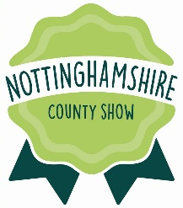
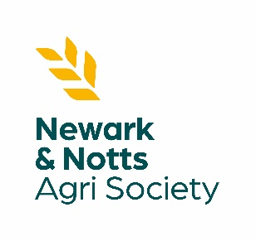
LONG SERVICE SINGLE
FARM AWARD - 2024

NOTTINGHAMSHIRE COUNTY SHOW
Saturday 11th May 2024

WHO CAN APPLY?

The Long Service Single Farm Award is open to Nottinghamshire residents and Society members in support of our charity’s objectives, which are to promote primary agriculture and related industries. Awards are issued to those who have worked for a single farm or employer for 25 years, 35 years, 45 years and 55 years’ service.

ENTRANT DETAILS:

FULL NAME: …………………………………………………………………………………………………………………………………………………………
(Block Capitals Please)

ADDRESS: ……………………………………………………………………………………………………………………………………………………………

…………………………………………………………………………………………………………………………………………………………………………..

………………………………………………………………………………………………… POST CODE:…………………………………………………..

Tel No: …………………………………………………………………. Mobile Tel No: ………………………………………………………………….

Date of Birth: ……………………………………………………….. Total Number of Years’ Service ………………………………………..

EMPLOYMENT HISTORY:

EMPLOYER’S NAME: ……………………………………………………………………………………………………………………………………………..
EMPLOYER’s ADDRESS: …………………………………………………………………………………………………………………………………………

…………………………………………………………………………………………………………………………………………………………………………..

………………………………………………………………………………………………… POST CODE:…………………………………………………..

Tel No: ……………………………………………………………………….. Email: …………………………………………………………………………

Date of Birth: ……………………………………………………………… Total Number of Years’ Service ………………………………….

From: …………………………………………………………………………. To: ……………………………………………………………………………..
EMPLOYER’S SIGNATURE: ………………………………………………………………………………………………………………………………………………….

NEWARK & NOTTINGHAMSHIRE AGRICULTURAL SOCIETY
Registered Charity No: 514080
LONG SERVICE SINGLE
FARM AWARD - 2024

NOTTINGHAMSHIRE COUNTY SHOW
Saturday 14th May 2024

CONDITIONS FOR ELIGIBILITY:

The agricultural worker must be in full-time employment on 1st January 2024. Entries will be accepted from any of the three categories listed below:

- Employees having worked the longest time on one farm in Nottinghamshire.
- Employees having worked the longest time with current employer in Nottinghamshire.
- Employees having worked the longest time with the ancestors of current employer in Nottinghamshire.

The period of service must be continuous (except for illness or Services in the HM Forces).

It is not necessary for the employer to reside in Nottinghamshire, but the farm at which the applicant is employed must be within the county boundary.

The winner will not be eligible to compete in future years.

Prizes will be presented by the President of the Society at the Show on Saturday 11th May 2024.

Please complete and return this entry form to Newark & Nottinghamshire Agricultural Society by MONDAY 1st APRIL 2024 either by post or email.

Newark Showground, Lincoln Road, Newark-on-Trent, Nottinghamshire, NG24 2NY

harriet.canovan@newarkshowground.com
NEWARK & NOTTINGHAMSHIRE AGRICULTURAL SOCIETY
Registered Charity No: 514080

