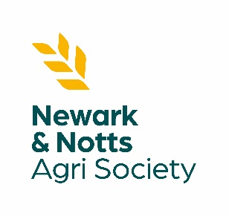
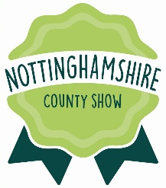
SERVICE TO AGRICULTURE
Award – 2024
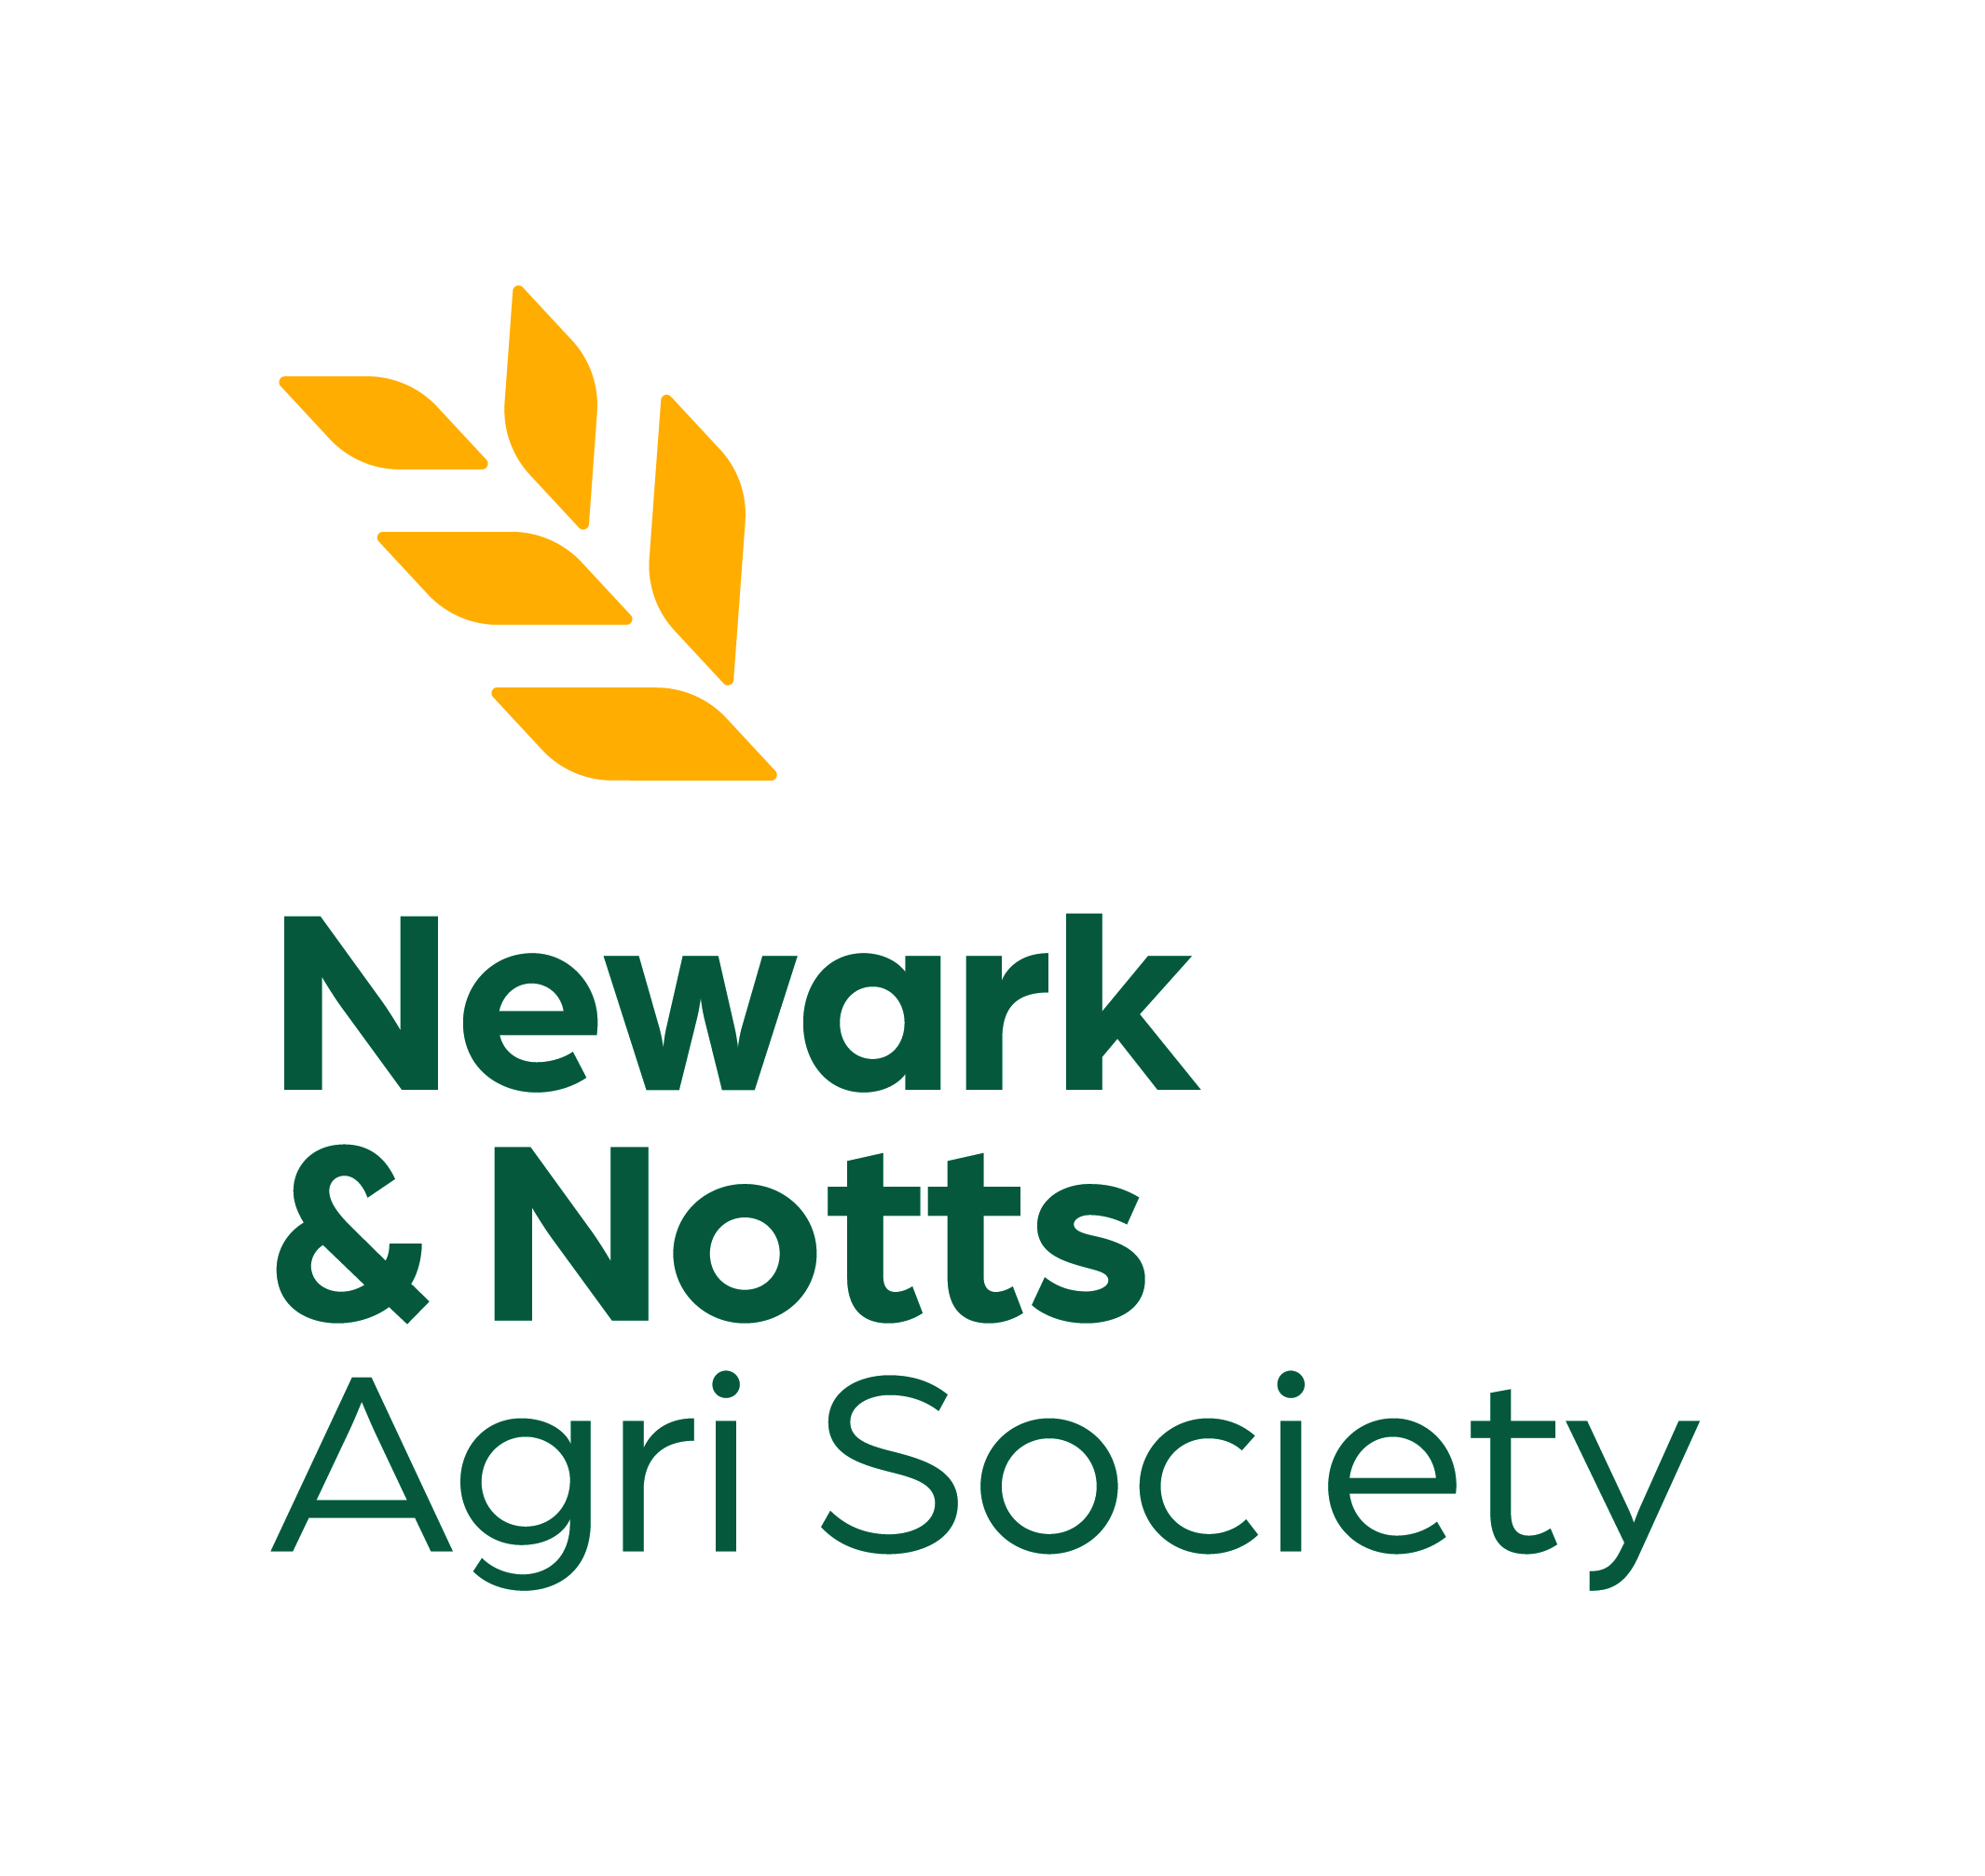

NOTTINGHAMSHIRE COUNTY SHOW
Saturday 11th May 2024

WHO CAN APPLY/NOMINTAED?

The Service to Agricultural Award is presented to individuals who have given outstanding service and contribution in support of our Charity’s objectives, which are to promote primary agriculture and related industries. The award is open to East Midlands residents, Society members and individuals who have inspired, led and shaped the agricultural sector.

ENTRANT DETAILS:

FULL NAME: …………………………………………………………………………………………………………………………………………………………
(Block Capitals Please)

ADDRESS: ……………………………………………………………………………………………………………………………………………………………

…………………………………………………………………………………………………………………………………………………………………………..

………………………………………………………………………………………………… POSTCODE: …………………………………………………….

Email Address: …………………………………………………………………. Contact Tel No: ……………………………………………………
(Please print clearly or we may not be able to contact you)

DETAILS OF AGRICULTURAL SERVICE & WHY THEY/YOU SHOULD BE RECOGNISED:

…………………………………………………………………………………………………………………………………………………………………………..

…………………………………………………………………………………………………………………………………………………………………………..

…………………………………………………………………………………………………………………………………………………………………………..

…………………………………………………………………………………………………………………………………………………………………………..

…………………………………………………………………………………………………………………………………………………………………………..

…………………………………………………………………………………………………………………………………………………………………………..

…………………………………………………………………………………………………………………………………………………………………………..

NEWARK & NOTTINGHAMSHIRE AGRICULTURAL SOCIETY
Registered Charity No: 514080
SERVICE TO AGRICULTURE
Award - 2024

NOTTINGHAMSHIRE COUNTY SHOW
Saturday 11th May 2024

DETAILS OF AGRICULTURAL SERVICE & WHY THEY/YOU SHOULD BE RECOGNISED: (CONTINUED)

…………………………………………………………………………………………………………………………………………………………………………..

…………………………………………………………………………………………………………………………………………………………………………..

…………………………………………………………………………………………………………………………………………………………………………..

…………………………………………………………………………………………………………………………………………………………………………..

…………………………………………………………………………………………………………………………………………………………………………..

…………………………………………………………………………………………………………………………………………………………………………..

…………………………………………………………………………………………………………………………………………………………………………..

WITNESS STATEMENT:
I confirm that I know the applicant and agree with the information provided.
NAME OF WITNESS: ……………………………………………………………………………………………………………………………………………..

Tel No: ……………………………………………………………………….. Email: …………………………………………………………………………

WITNESS SIGNATURE: ………………………………………………………………………………………………………………………………………………….

Please complete and return this entry form to Newark & Nottinghamshire Agricultural Society no later than MONDAY 1st APRIL 2024 either by post or email.

Newark Showground, Lincoln Road, Newark-on-Trent, Nottinghamshire, NG24 2NY

harriet.canovan@newarkshowground.com

NEWARK & NOTTINGHAMSHIRE AGRICULTURAL SOCIETY
Registered Charity No: 514080
NEWARK & NOTTINGHAMSHIRE AGRICULTURAL SOCIETY
Registered Charity No: 514080

